1 run

training 1 epoch...

1.6616759300231934 seconds used......

1 training finished! average train loss: 1.1151282946268717

evaluating...

Confusion matrix, without normalization

[[ 11 2 0]

[ 17 12 0]

[243 49 48]]

Normalized confusion matrix

[[0.84615385 0.15384615 0. ]

[0.5862069 0.4137931 0. ]

[0.71470588 0.14411765 0.14117647]]

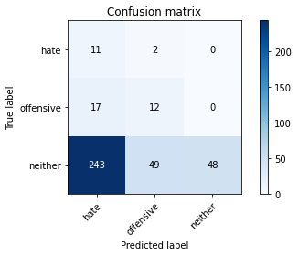

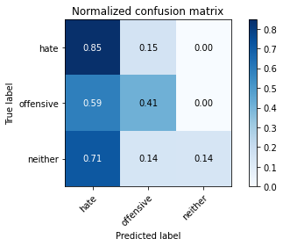

precision recall f1-score support

hate 0.04 0.85 0.08 13

offensive 0.19 0.41 0.26 29

neither 1.00 0.14 0.25 340

accuracy 0.19 382

macro avg 0.41 0.47 0.20 382

weighted avg 0.91 0.19 0.24 382

average eval_loss: 1.2250327110290526, accuracy: 0.18586387434554974

training 2 epoch...

1.6475367546081543 seconds used......

2 training finished! average train loss: 1.0350828210512797

evaluating...

Confusion matrix, without normalization

[[ 2 3 8]

[ 4 9 16]

[ 42 32 266]]

Normalized confusion matrix

[[0.15384615 0.23076923 0.61538462]

[0.13793103 0.31034483 0.55172414]

[0.12352941 0.09411765 0.78235294]]

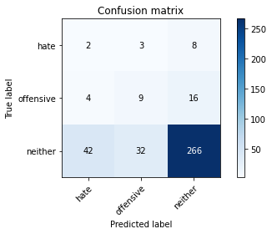

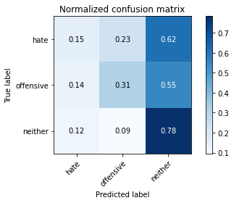

precision recall f1-score support

hate 0.04 0.15 0.07 13

offensive 0.20 0.31 0.25 29

neither 0.92 0.78 0.84 340

accuracy 0.73 382

macro avg 0.39 0.42 0.39 382

weighted avg 0.83 0.73 0.77 382

average eval_loss: 0.9221169531345368, accuracy: 0.725130890052356

training 3 epoch...

1.649641513824463 seconds used......

3 training finished! average train loss: 0.9620448629061381

evaluating...

Confusion matrix, without normalization

[[ 8 4 1]

[ 10 17 2]

[152 68 120]]

Normalized confusion matrix

[[0.61538462 0.30769231 0.07692308]

[0.34482759 0.5862069 0.06896552]

[0.44705882 0.2 0.35294118]]

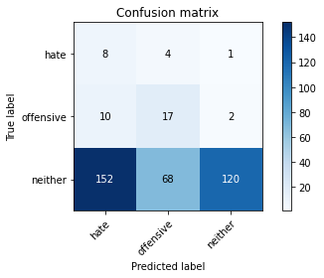

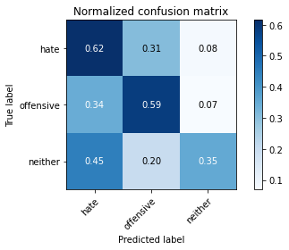

precision recall f1-score support

hate 0.05 0.62 0.09 13

offensive 0.19 0.59 0.29 29

neither 0.98 0.35 0.52 340

accuracy 0.38 382

macro avg 0.40 0.52 0.30 382

weighted avg 0.88 0.38 0.49 382

average eval_loss: 1.0965665966272353, accuracy: 0.3795811518324607

training 4 epoch...

1.652538537979126 seconds used......

4 training finished! average train loss: 0.8602852980295818

evaluating...

Confusion matrix, without normalization

[[ 5 7 1]

[ 6 22 1]

[ 85 139 116]]

Normalized confusion matrix

[[0.38461538 0.53846154 0.07692308]

[0.20689655 0.75862069 0.03448276]

[0.25 0.40882353 0.34117647]]

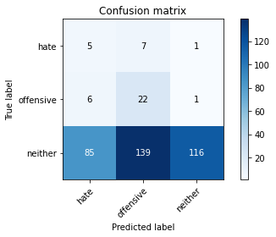

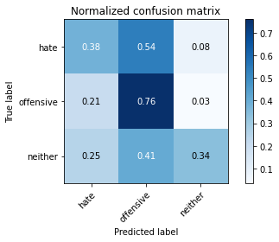

precision recall f1-score support

hate 0.05 0.38 0.09 13

offensive 0.13 0.76 0.22 29

neither 0.98 0.34 0.51 340

accuracy 0.37 382

macro avg 0.39 0.49 0.27 382

weighted avg 0.89 0.37 0.47 382

average eval_loss: 1.1120426386594773, accuracy: 0.3743455497382199

training 5 epoch...

1.6804707050323486 seconds used......

5 training finished! average train loss: 0.673955915371577

evaluating...

Confusion matrix, without normalization

[[ 6 4 3]

[ 7 12 10]

[ 60 57 223]]

Normalized confusion matrix

[[0.46153846 0.30769231 0.23076923]

[0.24137931 0.4137931 0.34482759]

[0.17647059 0.16764706 0.65588235]]

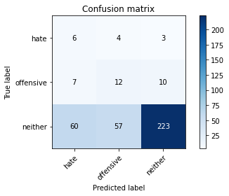

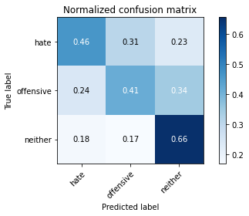

precision recall f1-score support

hate 0.08 0.46 0.14 13

offensive 0.16 0.41 0.24 29

neither 0.94 0.66 0.77 340

accuracy 0.63 382

macro avg 0.40 0.51 0.38 382

weighted avg 0.86 0.63 0.71 382

average eval_loss: 0.9119860023260117, accuracy: 0.6308900523560209

model of 1 epoch

Confusion matrix, without normalization

[[ 34 6 1]

[ 91 4 0]

[533 94 87]]

Normalized confusion matrix

[[0.82926829 0.14634146 0.02439024]

[0.95789474 0.04210526 0. ]

[0.7464986 0.13165266 0.12184874]]

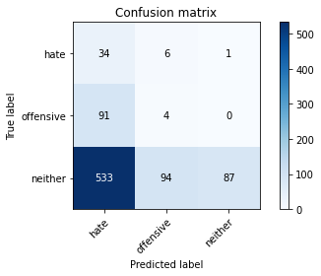

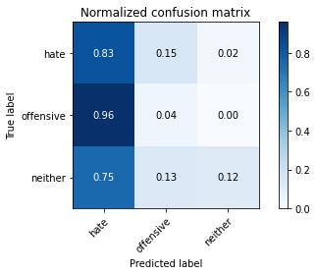

precision recall f1-score support

hate 0.05 0.83 0.10 41

offensive 0.04 0.04 0.04 95

neither 0.99 0.12 0.22 714

accuracy 0.15 850

macro avg 0.36 0.33 0.12 850

weighted avg 0.84 0.15 0.19 850

average eval_loss: 1.246176260848378, accuracy: 0.14705882352941177

0.14705882352941177

2 run

training 1 epoch...

1.821373701095581 seconds used......

1 training finished! average train loss: 1.0997337341308593

evaluating...

Confusion matrix, without normalization

[[ 3 7 3]

[ 2 18 9]

[ 61 142 137]]

Normalized confusion matrix

[[0.23076923 0.53846154 0.23076923]

[0.06896552 0.62068966 0.31034483]

[0.17941176 0.41764706 0.40294118]]

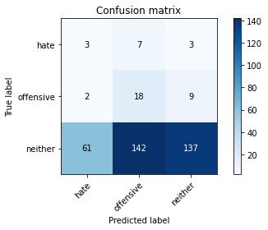

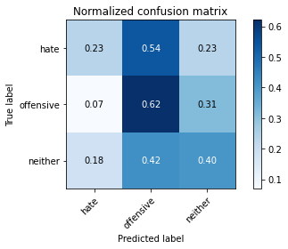

precision recall f1-score support

hate 0.05 0.23 0.08 13

offensive 0.11 0.62 0.18 29

neither 0.92 0.40 0.56 340

accuracy 0.41 382

macro avg 0.36 0.42 0.27 382

weighted avg 0.83 0.41 0.52 382

average eval_loss: 1.08970365524292, accuracy: 0.41361256544502617

training 2 epoch...

1.8071837425231934 seconds used......

2 training finished! average train loss: 1.0320179422696432

evaluating...

Confusion matrix, without normalization

[[ 2 7 4]

[ 3 15 11]

[ 55 65 220]]

Normalized confusion matrix

[[0.15384615 0.53846154 0.30769231]

[0.10344828 0.51724138 0.37931034]

[0.16176471 0.19117647 0.64705882]]

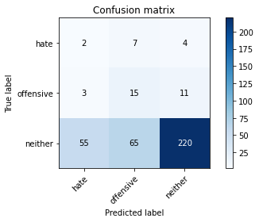

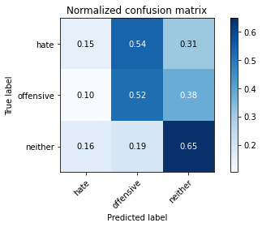

precision recall f1-score support

hate 0.03 0.15 0.05 13

offensive 0.17 0.52 0.26 29

neither 0.94 0.65 0.77 340

accuracy 0.62 382

macro avg 0.38 0.44 0.36 382

weighted avg 0.85 0.62 0.70 382

average eval_loss: 1.0160289108753204, accuracy: 0.6204188481675392

training 3 epoch...

1.8419499397277832 seconds used......

3 training finished! average train loss: 0.959736720720927

evaluating...

Confusion matrix, without normalization

[[ 3 7 3]

[ 8 16 5]

[108 81 151]]

Normalized confusion matrix

[[0.23076923 0.53846154 0.23076923]

[0.27586207 0.55172414 0.17241379]

[0.31764706 0.23823529 0.44411765]]

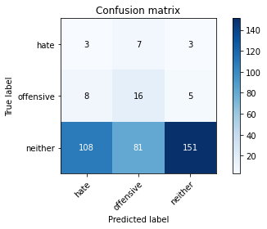

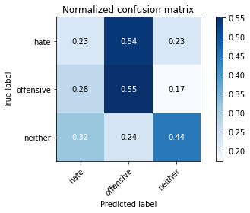

precision recall f1-score support

hate 0.03 0.23 0.05 13

offensive 0.15 0.55 0.24 29

neither 0.95 0.44 0.61 340

accuracy 0.45 382

macro avg 0.38 0.41 0.30 382

weighted avg 0.86 0.45 0.56 382

average eval_loss: 1.0469849109649658, accuracy: 0.44502617801047123

training 4 epoch...

1.9195420742034912 seconds used......

4 training finished! average train loss: 0.8543500065803528

evaluating...

Confusion matrix, without normalization

[[ 3 7 3]

[ 4 18 7]

[ 77 94 169]]

Normalized confusion matrix

[[0.23076923 0.53846154 0.23076923]

[0.13793103 0.62068966 0.24137931]

[0.22647059 0.27647059 0.49705882]]

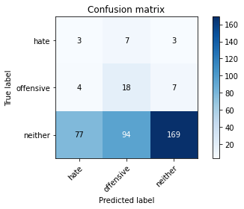

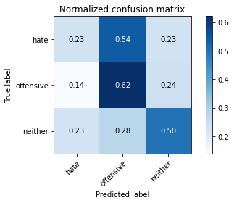

precision recall f1-score support

hate 0.04 0.23 0.06 13

offensive 0.15 0.62 0.24 29

neither 0.94 0.50 0.65 340

accuracy 0.50 382

macro avg 0.38 0.45 0.32 382

weighted avg 0.85 0.50 0.60 382

average eval_loss: 1.0317823529243468, accuracy: 0.4973821989528796

training 5 epoch...

1.82342529296875 seconds used......

5 training finished! average train loss: 0.7001521428426106

evaluating...

Confusion matrix, without normalization

[[ 5 7 1]

[ 7 16 6]

[100 71 169]]

Normalized confusion matrix

[[0.38461538 0.53846154 0.07692308]

[0.24137931 0.55172414 0.20689655]

[0.29411765 0.20882353 0.49705882]]

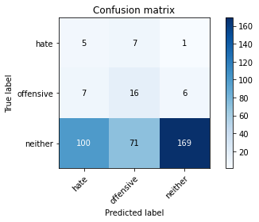

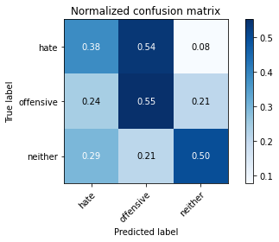

precision recall f1-score support

hate 0.04 0.38 0.08 13

offensive 0.17 0.55 0.26 29

neither 0.96 0.50 0.66 340

accuracy 0.50 382

macro avg 0.39 0.48 0.33 382

weighted avg 0.87 0.50 0.61 382

average eval_loss: 1.0387089818716049, accuracy: 0.4973821989528796

Confusion matrix, without normalization

[[ 28 9 4]

[ 32 45 18]

[249 140 325]]

Normalized confusion matrix

[[0.68292683 0.2195122 0.09756098]

[0.33684211 0.47368421 0.18947368]

[0.3487395 0.19607843 0.45518207]]

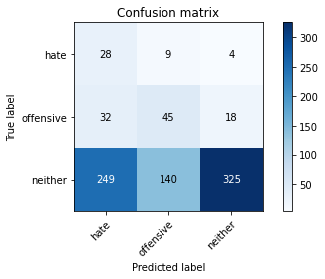

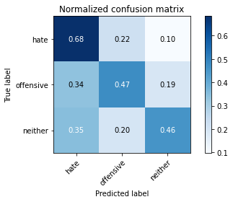

precision recall f1-score support

hate 0.09 0.68 0.16 41

offensive 0.23 0.47 0.31 95

neither 0.94 0.46 0.61 714

accuracy 0.47 850

macro avg 0.42 0.54 0.36 850

weighted avg 0.82 0.47 0.56 850

average eval_loss: 1.0642748128536135, accuracy: 0.4682352941176471

[25]:

0.4682352941176471

3 run

training 1 epoch...

1.8290519714355469 seconds used......

1 training finished! average train loss: 1.1159669001897177

evaluating...

Confusion matrix, without normalization

[[ 0 5 8]

[ 1 18 10]

[ 52 105 183]]

Normalized confusion matrix

[[0. 0.38461538 0.61538462]

[0.03448276 0.62068966 0.34482759]

[0.15294118 0.30882353 0.53823529]]

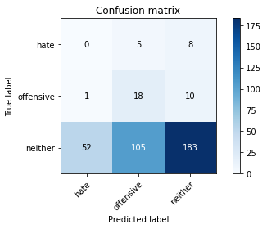

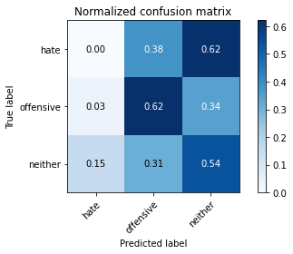

precision recall f1-score support

hate 0.00 0.00 0.00 13

offensive 0.14 0.62 0.23 29

neither 0.91 0.54 0.68 340

accuracy 0.53 382

macro avg 0.35 0.39 0.30 382

weighted avg 0.82 0.53 0.62 382

average eval_loss: 1.0646141111850738, accuracy: 0.5261780104712042

training 2 epoch...

1.8142814636230469 seconds used......

2 training finished! average train loss: 1.0386577129364014

evaluating...

Confusion matrix, without normalization

[[ 1 3 9]

[ 3 15 11]

[ 67 54 219]]

Normalized confusion matrix

[[0.07692308 0.23076923 0.69230769]

[0.10344828 0.51724138 0.37931034]

[0.19705882 0.15882353 0.64411765]]

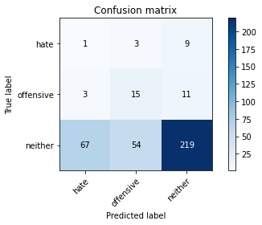

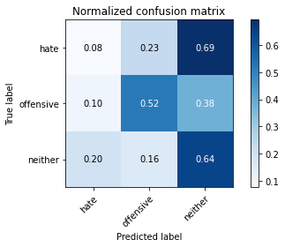

precision recall f1-score support

hate 0.01 0.08 0.02 13

offensive 0.21 0.52 0.30 29

neither 0.92 0.64 0.76 340

accuracy 0.62 382

macro avg 0.38 0.41 0.36 382

weighted avg 0.83 0.62 0.70 382

average eval_loss: 1.0169158637523652, accuracy: 0.6151832460732984

training 3 epoch...

2.09936785697937 seconds used......

3 training finished! average train loss: 0.9784852027893066

evaluating...

Confusion matrix, without normalization

[[ 5 5 3]

[ 8 14 7]

[144 55 141]]

Normalized confusion matrix

[[0.38461538 0.38461538 0.23076923]

[0.27586207 0.48275862 0.24137931]

[0.42352941 0.16176471 0.41470588]]

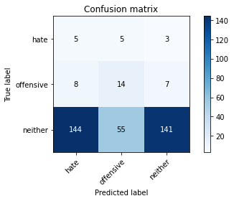

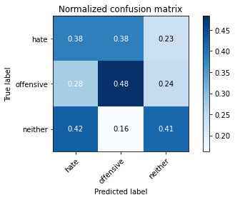

precision recall f1-score support

hate 0.03 0.38 0.06 13

offensive 0.19 0.48 0.27 29

neither 0.93 0.41 0.57 340

accuracy 0.42 382

macro avg 0.38 0.43 0.30 382

weighted avg 0.85 0.42 0.53 382

average eval_loss: 1.0289405047893525, accuracy: 0.418848167539267

training 4 epoch...

1.8057997226715088 seconds used......

4 training finished! average train loss: 0.8978977719942729

evaluating...

Confusion matrix, without normalization

[[ 4 5 4]

[ 4 17 8]

[ 92 66 182]]

Normalized confusion matrix

[[0.30769231 0.38461538 0.30769231]

[0.13793103 0.5862069 0.27586207]

[0.27058824 0.19411765 0.53529412]]

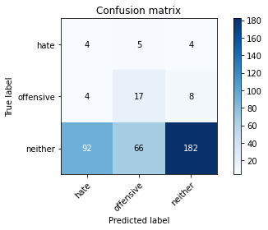

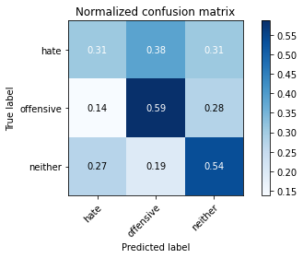

precision recall f1-score support

hate 0.04 0.31 0.07 13

offensive 0.19 0.59 0.29 29

neither 0.94 0.54 0.68 340

accuracy 0.53 382

macro avg 0.39 0.48 0.35 382

weighted avg 0.85 0.53 0.63 382

average eval_loss: 0.9843276917934418, accuracy: 0.5314136125654451

training 5 epoch...

1.8325424194335938 seconds used......

5 training finished! average train loss: 0.791049591700236

evaluating...

Confusion matrix, without normalization

[[ 4 6 3]

[ 2 21 6]

[ 71 106 163]]

Normalized confusion matrix

[[0.30769231 0.46153846 0.23076923]

[0.06896552 0.72413793 0.20689655]

[0.20882353 0.31176471 0.47941176]]

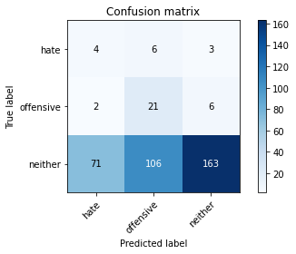

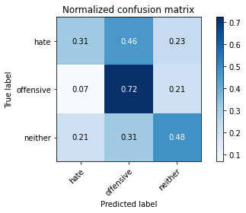

precision recall f1-score support

hate 0.05 0.31 0.09 13

offensive 0.16 0.72 0.26 29

neither 0.95 0.48 0.64 340

accuracy 0.49 382

macro avg 0.39 0.50 0.33 382

weighted avg 0.86 0.49 0.59 382

average eval_loss: 1.0293560653924942, accuracy: 0.49214659685863876

Confusion matrix, without normalization

[[ 30 10 1]

[ 56 27 12]

[350 145 219]]

Normalized confusion matrix

[[0.73170732 0.24390244 0.02439024]

[0.58947368 0.28421053 0.12631579]

[0.49019608 0.20308123 0.30672269]]

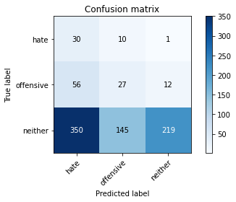

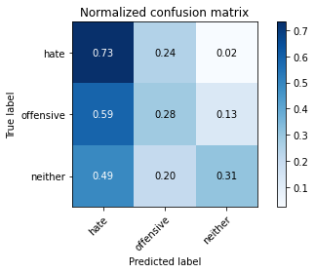

precision recall f1-score support

hate 0.07 0.73 0.13 41

offensive 0.15 0.28 0.19 95

neither 0.94 0.31 0.46 714

accuracy 0.32 850

macro avg 0.39 0.44 0.26 850

weighted avg 0.81 0.32 0.42 850

average eval_loss: 1.1069668101709942, accuracy: 0.3247058823529412

[27]:

0.3247058823529412